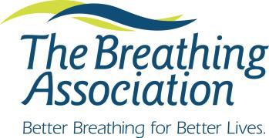
Tobacco Treatment Specialist Recertification
Continuing Education Documentation

Directions: The Breathing Association TTS Certificate is valid for two years. Recertification requires proof of continuing education from an accredited organization, on tobacco cessation, prevention, health policy, or closely related areas such as behavioral health and counseling, with 18 hours training during the two-year interval. Please complete this form (both pages) and attach copies of certificates demonstrating continuing education hours received. Documents may be scanned and emailed to the contact person listed at the bottom of this form. Please use an additional sheet if necessary to list continuing education. An example is provided in the first line of the table for your reference*.

Name:

Home address: ________________________________________________________________________________

City, State__________________________________________ Zip________ County________________________

Home or Cell phone____________________________ Personal email___________________________________

Place of employment___________________________________________________________________________

Work Address_________________________________________________________________________________

Work Phone_________________________________ Work email______________________________________

TTS Number_______________________________ Date TTS Certificate was received_____________________
********** Cost for Recertification is $100.00 **********
Paying by check or money order: Y N please include when mailing application.
Paying by credit card: Y N after application has been received and reviewed, you will receive an email invoice from
Paytrace allowing you to pay and receive a receipt.

I attest that the listed continuing education hours were received by me and that the information presented is accurate.

Signed Date _____

Please Mail Forms to:
Heather McCary Phone: 614-437-1521
The Breathing Association Fax: 614-437-1506
788 Mt. Vernon Avenue E-mail heather.mccary@breathingassociation.org
Columbus, OH 43203

*Please use the table in the second sheet to document your continuing education hours.

Date of Continuing Education | Title of Workshop | Content Summary | Total Hours Received
1/1/2015 | Secondhand Smoke: The Dangers | Session focused on exposure to secondhand smoke. | 1.5

