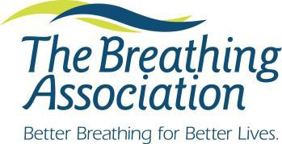
Tobacco Treatment Specialist Recertification Application

Directions: In order to maintain a current CTTS Certificate you will need to renew your certification every two years (from the date on your initial certificate). Recertification requires proof of 18 continuing education credits from an accredited organization, on tobacco cessation, prevention, health policy, or closely related areas such as behavioral health and counseling. Please complete this form (both pages) and attach copies of certificates demonstrating continuing education hours received. Documents may be emailed or mailed (USPS) to the contact person listed at the bottom of this form.

Name:

Home address:

City, State Zip County

Home or Cell phone Personal email

Place of employment

Work Address

Work Phone Work email

TTS Number Date TTS Certificate was received

********** Cost for Recertification is $100.00 **********

****PLEASE INDICATE WHO THE INVOICE WILL BE PAID BY: MYSELF MY EMPLOYER
Please indicate your method of payment (check, money order or credit card)
**Paying by check/money order: Please email Davan.Oreilly@breathingassociation.org to request an invoice be emailed to you to include with your mailed in application and payment.
**Paying by credit card: Please email your completed application and CE certificates to: Davan.Oreilly@breathingassociation.org . you will be emailed an invoice from The Breathing Association & a separate email from Paytrace will contain a payment link (allowing you to pay by credit card and receive a receipt). **The payment link will expire after 10 days***

I attest that the listed continuing education hours were received by me and that the information presented is accurate.

Signed Date

Please Mail Forms to:
Davan O'Reilly
The Breathing Association 788 Mt. Vernon Avenue Columbus, OH 43203
Phone: 614-437-1521
Fax: 614-437-1506
Email: davan.oreilly@breathingassociation.org

Date of Continuing Education | Title of Workshop | Content Summary | Total  Hours Received
1/1/2015 | Secondhand Smoke: The Dangers | Session focused on exposure to secondhand smoke. | 1.5

